Name: Ryan C. Elico Section: BSIT – 501

1. LOGGING IN

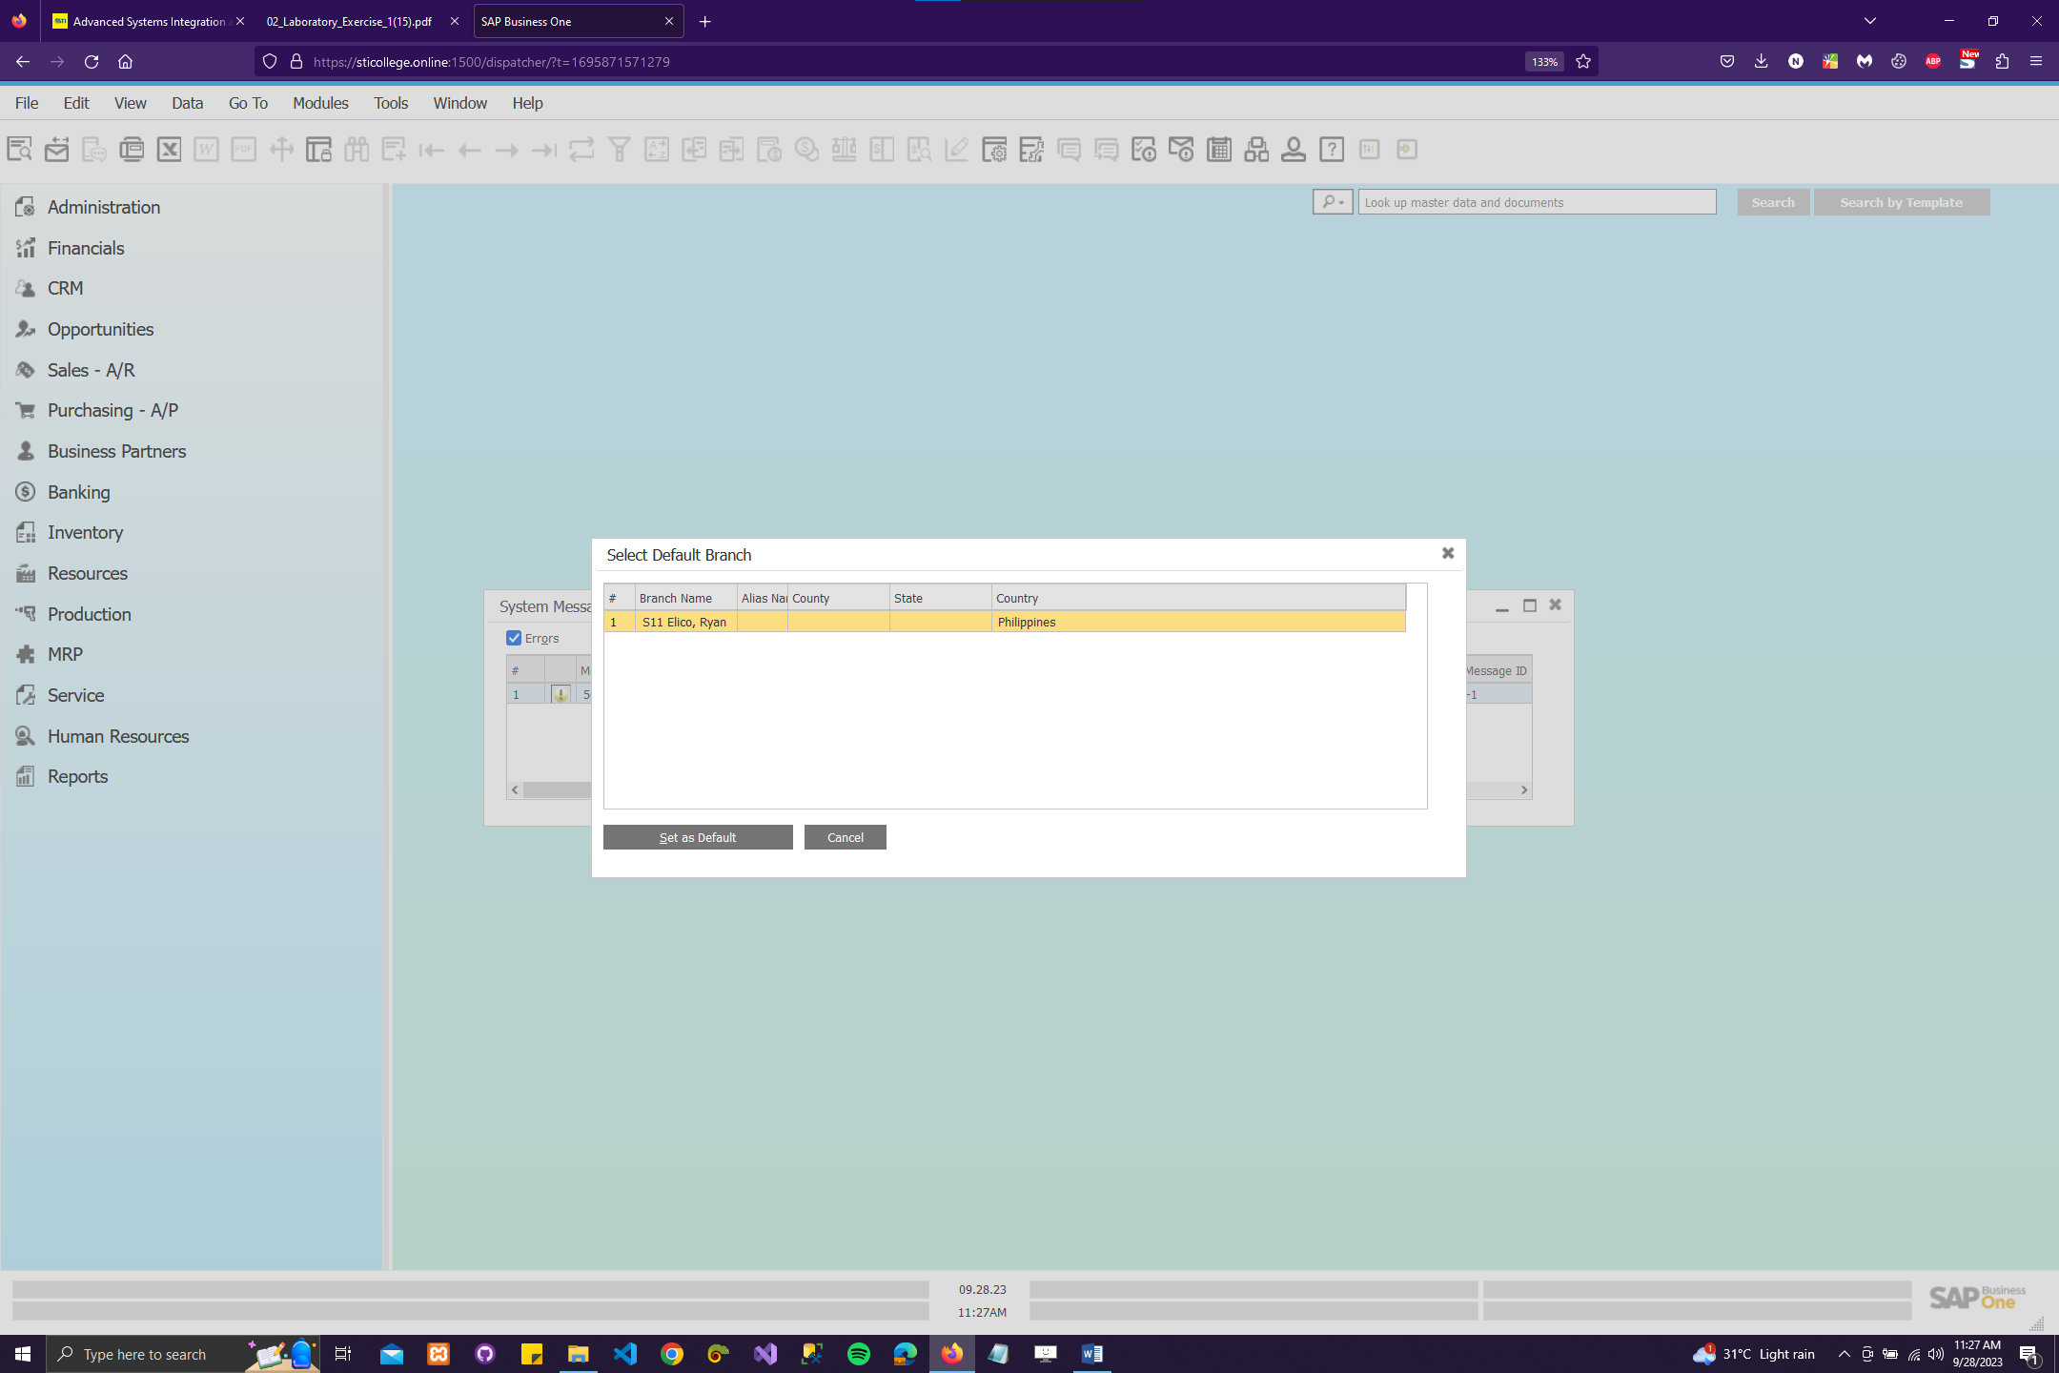

Caption: As a student, the process of using SAP B1 begins with logging in. This involves opening a web browser and entering the URL provided by the instructor. Next, I select the assigned server and company, which are also provided by the instructor. Then, I log in using the user ID and password specific to the branch assigned to me, as each student has a unique branch assignment. It's crucial to remember to set the default branch assigned to me once I'm logged in to ensure seamless operation within SAP B1.

1. COMPANY DETAILS (Section 1 of Business Blueprint)

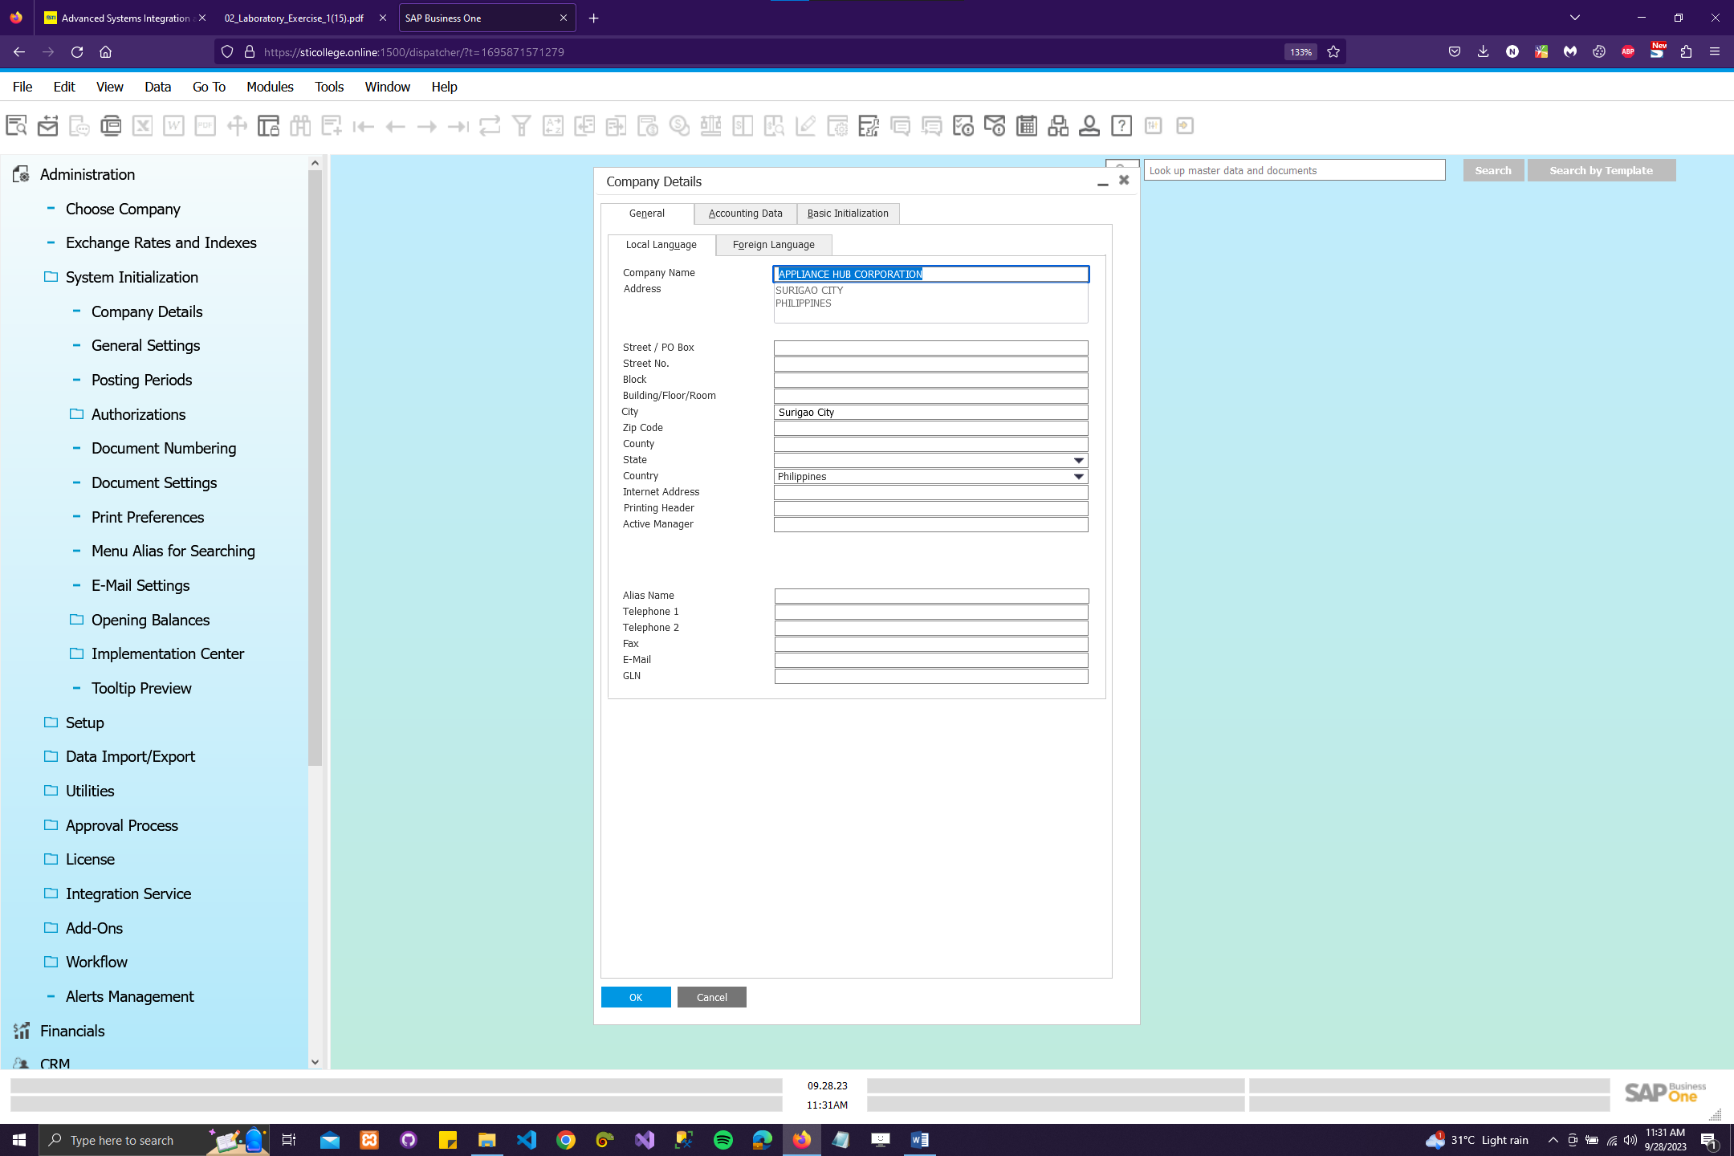

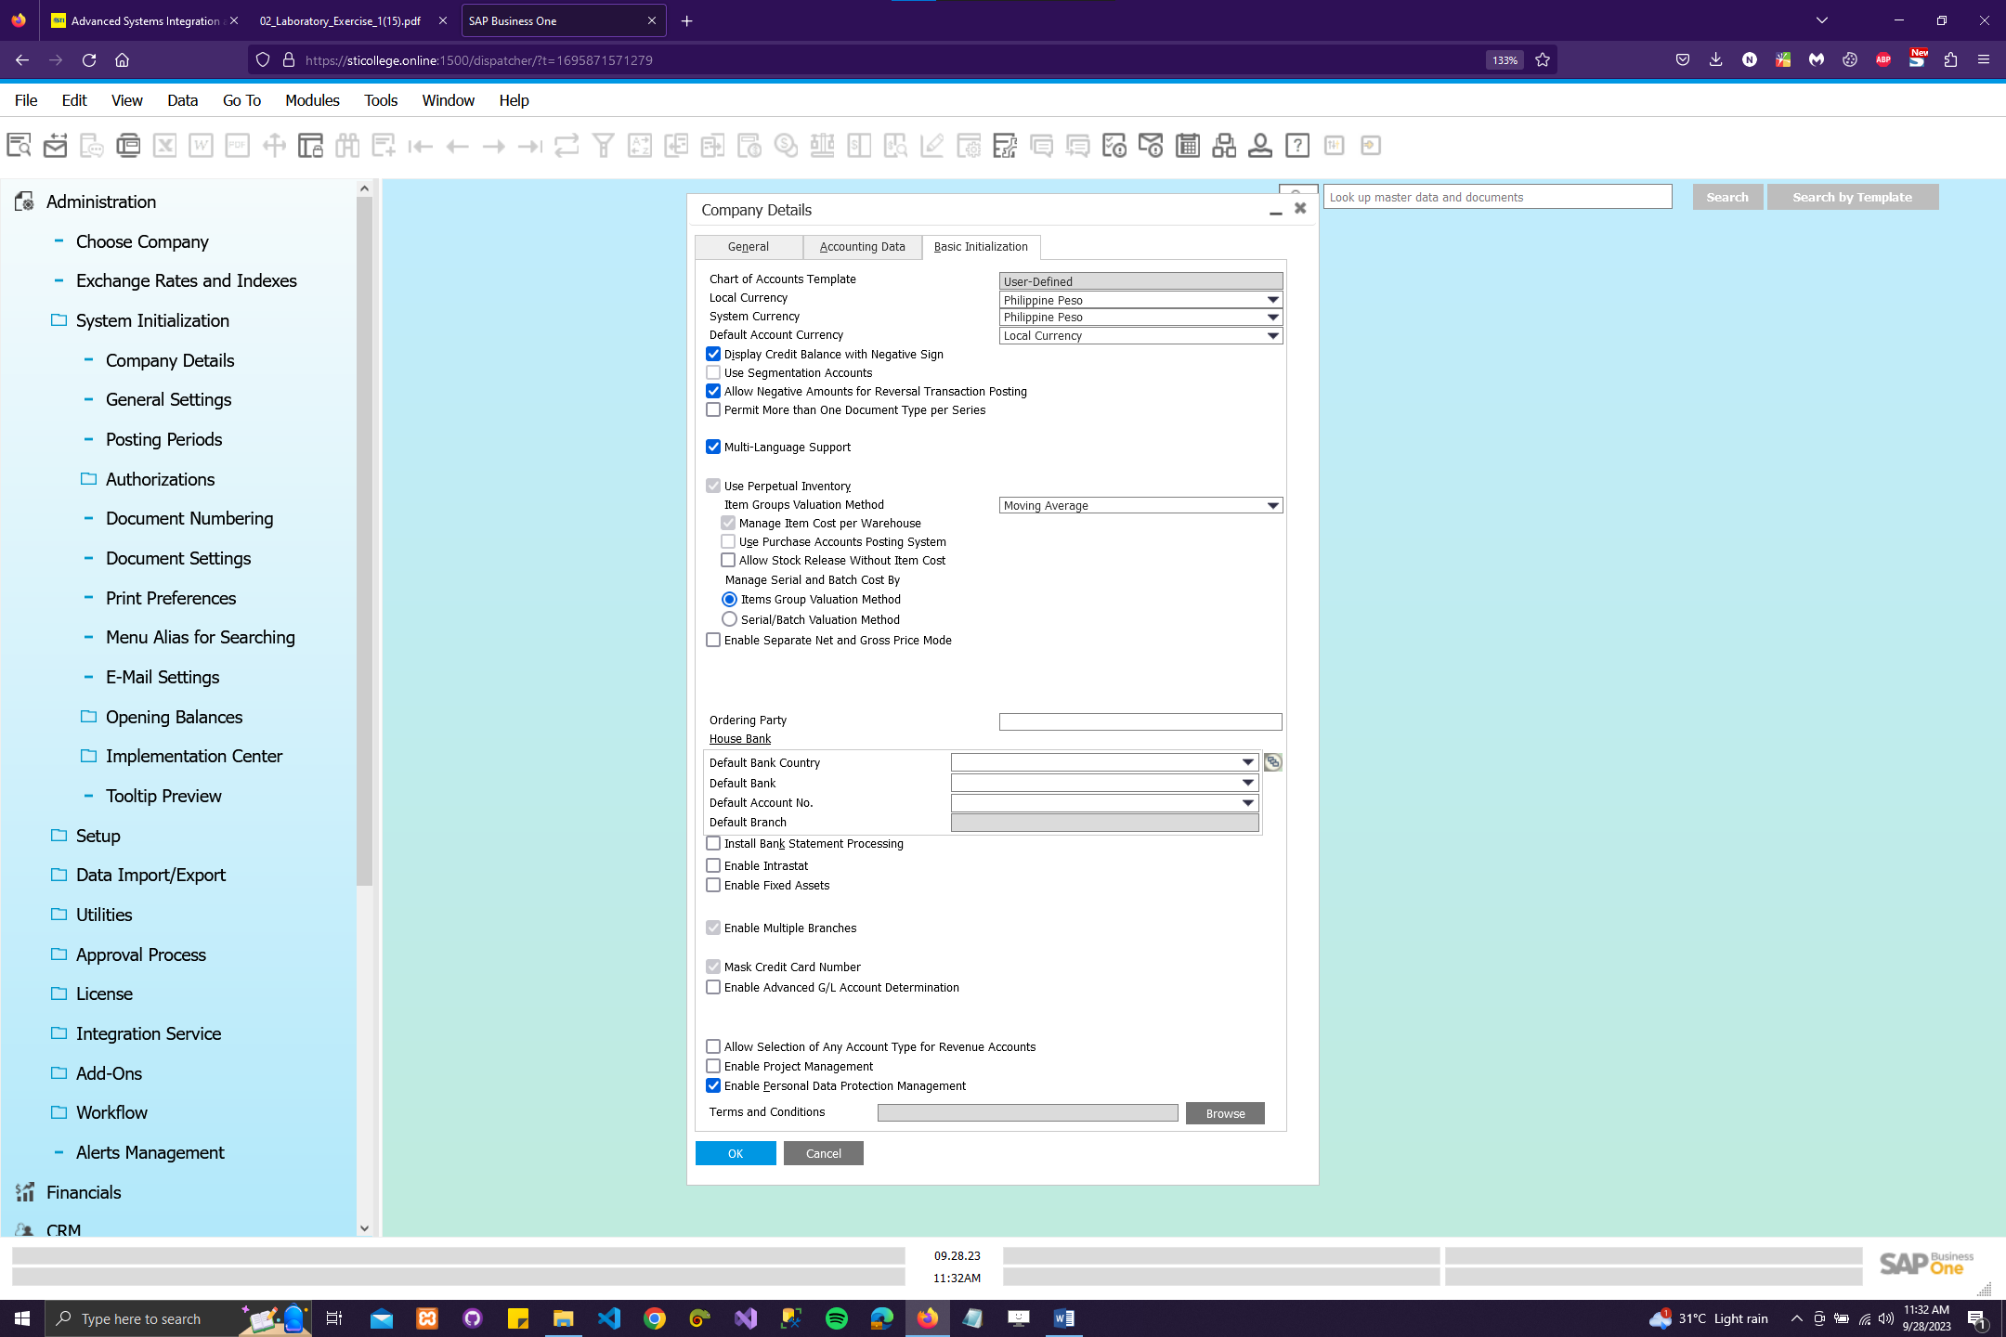

Caption: As a student using SAP Business One (SAP B1), the process of entering company details in Section 1 of the Business Blueprint begins by inputting the company name, address, and other necessary information. Next, I navigate to Administration > System Initialization > Company Details > General Tab > Local Language. Here, I observe that the Address field updates automatically based on the input in the boxes below it. I capture the company details and paste them into my document before clicking Update and proceeding to the Basic Initialization tab. In the Basic Initialization tab, I enter "Philippine Peso" in the Local Currency and System Currency fields. If this option is unavailable, I click on Define New to add the new currency. After capturing the updated Basic Initialization tab and labeling it as "Company Details," I click Update and then OK. Lastly, I check and select specific options as required, and once again, click Update and OK to complete the process.

1. GENERAL SETTINGS (Section 2 of the Business Blueprint)

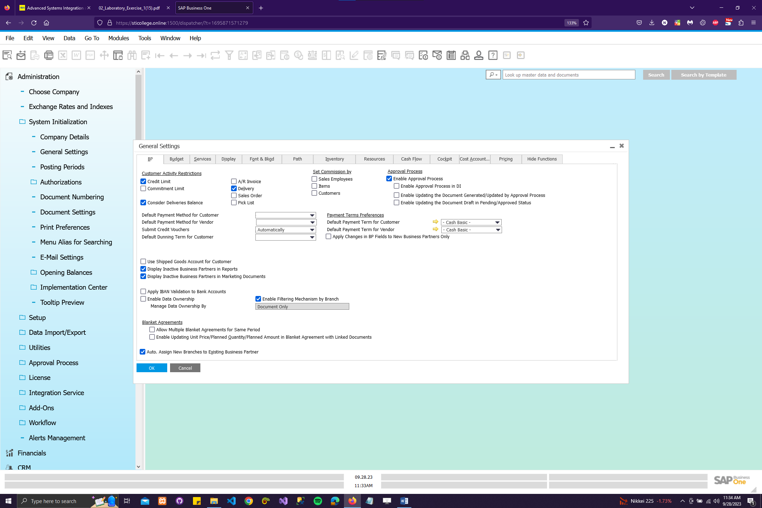

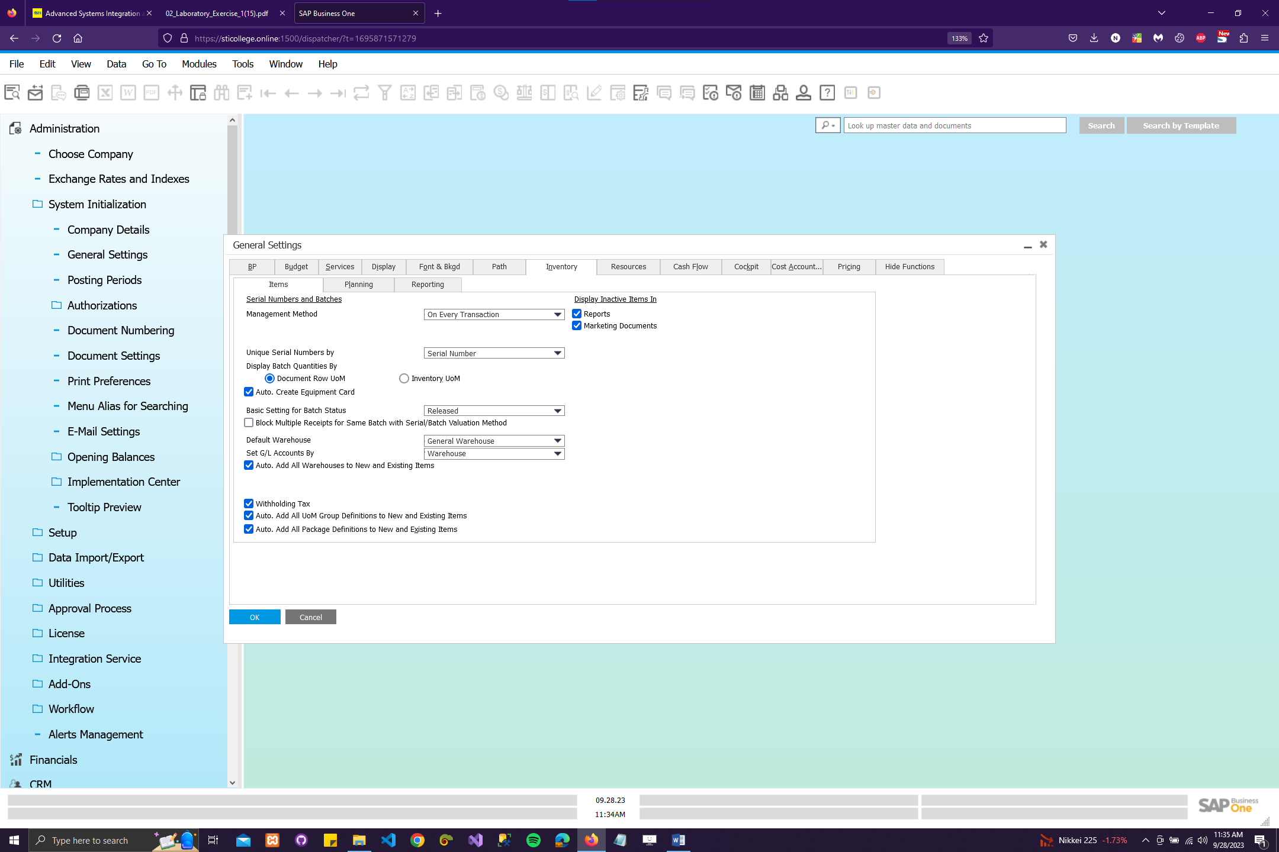

Caption: As a student using SAP Business One, I begin by configuring the general settings in Section 2 of the Business Blueprint. First, I navigate to Administration, then System Initialization, and select General Settings, followed by the BP Tab. Here, I carefully review and ensure that all the selections match those in the sample image for BP Settings. After confirming this, I click on Update to save the changes and then proceed to the Inventory tab. In the Inventory tab, I once again review and verify that all the selections align with the sample image for Inventory Settings. Once confirmed, I click on Update to save the changes and then click OK to complete the setup process. This meticulous configuration ensures that SAP Business One is tailored to meet the specific needs of the business, providing an efficient and streamlined operational environment.